Assignment: Deploy a 3-Tier Web Application on AWS
Submitted by:
Name: Akib Ahmed
Email: ahmed22205101902@diu.edu.bd
Submitted to:
OSTAD DevOps Course Batch 8 assignment evaluator.

Cloned repo from: https://github.com/md-sarowar-alam/single-server-3tier-webapp
- EC2 instance running (AWS Console)
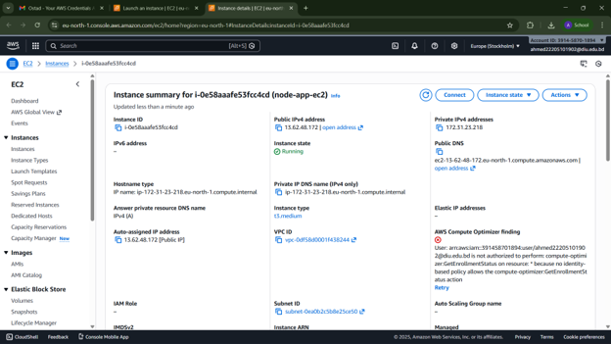
- VPC configuration (if VPC option is chosen)
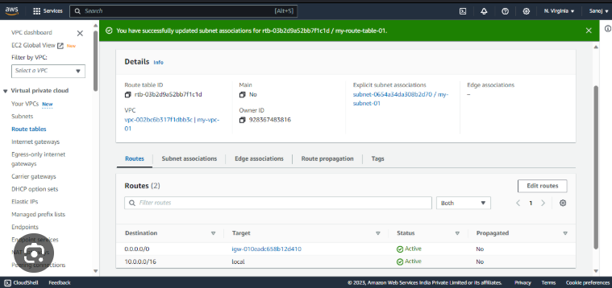
- Security Group inbound rules
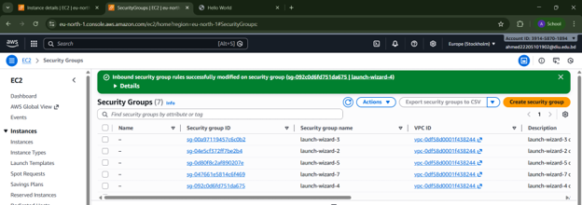
- Application running in the browser (Frontend UI)
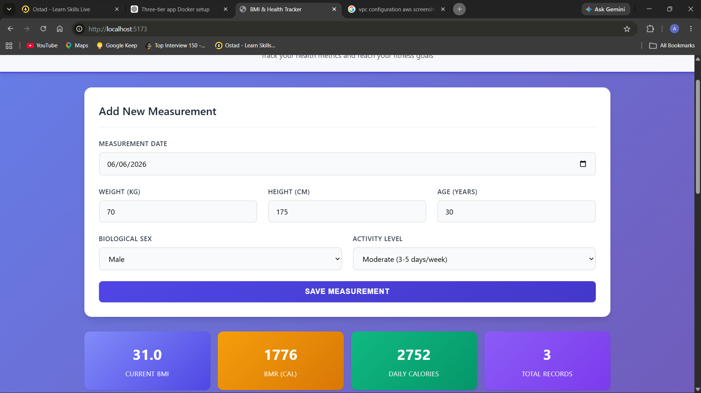
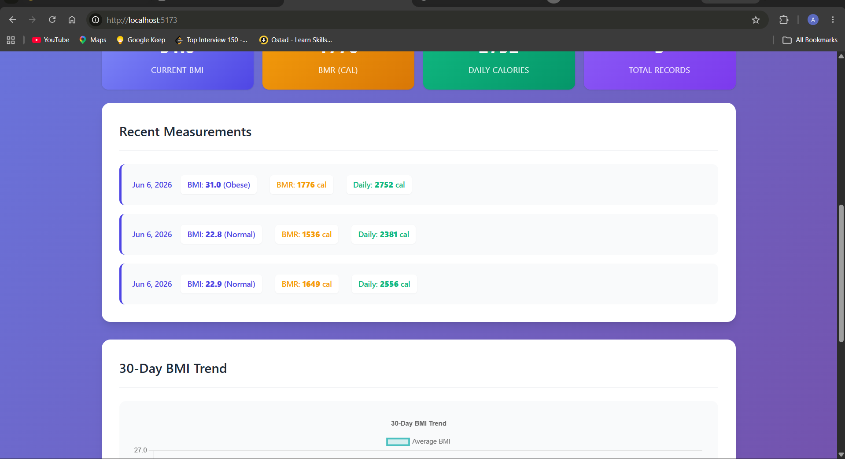
- Backend service running (terminal screenshot)
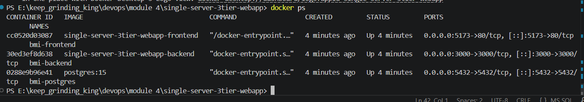
- Database service running (terminal screenshot)


